REVISION HISTORY

| Date | Version | Description | Author |
| --- | --- | --- | --- |
| 23.10.2024 | 1.0 | Added Use Cases and Usage Scenarios | Eda Nur Yılmaz |
| 24.10.2024 | 1.1 | Added the system architecture | Doruk Esen |
| 25.10.2024 | 1.2 | Added the user requirements | D. Yağmur Uğut |
| 25.10.2024 | 1.3 | Added conventions | Poyraz KÖROĞLU |
| 25.10.2024 | 1.4 | Added System Requirement Specifications | Ömer Emre Bozkurt |
| 26.10.2024 | 1.5 | Updated Use Cases and Usage Scenarios | Eda Nur Yılmaz |
| 01.11.2024 | 1.6 | Updated SRS-SB-002.2 and SRS-SB-003.1 according to feedback given | Ömer Emre Bozkurt |
| 03.11.2024 | 1.7 | Corrected the user-system requirements that were not matching, added some new ones. | Poyraz KÖROĞLU |

**TABLE OF CONTENTS**

**Revision History 1**

**1 INTRODUCTION 3**

1.1 Document overview 3

1.2 System overview 3

1.3 Abbreviations 3

1.4 References 3

1.5 Conventions 3

**2 REQUIREMENTS 4**

2.1 User Requirements Specification 4

2.2 System Architecture 5

2.3 Use Cases and Usage Scenarios 6

2.4 System Requirements Specification 7

# **INTRODUCTION**

## ***Document overview***

This document presents the software requirements specifications of the SB software development project. It describes functional requirements, quality requirements, constraints, use cases, and usage scenarios an provides an overview of the system architecture.

## ***System overview***

Our project SB will be a classic arcade game for computers. The game app will be accessible directly from the desktop and won’t need an internet connection. The game will take the best of the classical arcade games “Space Invaders” and “Pong”. Instead of directly shooting hostiles from a spaceship, We will use a ball and a rectangular shape which the ball will bounce off of to eliminate the hostiles. We hope that this will add mechanical depth to our game which the games we took elements from were missing.

## ***Abbreviations***

SB: Space Blasters

UML: Unified Modeling Language

IDE: Integrated Development Environment

JDK: Java Development Kit

SRS: Software Requirement Specification

STP: Software Test Plan

SDD: Software Design Document

STR: Software Test Report

VFX: Visual effects

SFX: Sound effects

## ***References***

| # | Document Identifier | Document Title |
| --- | --- | --- |
| [R1] | SB-SDP-v1.5 | “Software Development Plan of SB Software” |

## ***Conventions***

Requirements listed in this document are constructed according to the following structure:

**SRS-SB-001**

Description of SB-001 requirement

Every system requirement ID includes the ID of the corresponding user requirement as a prefix.

**SRS-SB-001.1**

Description of SRS-SB-001.1 system requirement, which is related to the user requirement SRS-SB-001

# **REQUIREMEN**TS

## ***User Requirements Specification***

## **SRS-SB-001**

SB shall enable players to see their high scores.

**SRS-SB-002**

SB shall enable players to start a new game.

**SRS-SB-003**

SB shall enable users to move their paddle with right and left arrow keys to right and left.

**SRS-SB-004**

SB shall enable players to hit the ball with the paddle.

**SRS-SB-005**

SB shall enable players to collect power-ups from special aliens that appear on the screen during gameplay.

**SRS-SB-006**

SB shall enable players to input their initials if they score in the top 5, which will be displayed on the high-score table.

**SRS-SB-007**

SB shall enable players to quit the game.

**SRS-SB-008**SB shall allow players to lose a life if they fail to hit the ball with the paddle, causing it to fall below it.

**SRS-SB-009**SB shall provide players with a set number of lives at the start of the game.

**SRS-SB-010**SB shall enable players to see the following on the game screen:

* Current score
* Number of lives remaining
* Active power-ups
* Current wave or level
* High score list (after Game Over)

**SRS-SB-011**

SB shall enable players to see the current score while they are playing.

**SRS-SB-012**

SB shall enable players to return to the main menu after the game ends.

**SRS-SB-013**

SB shall enable players to damage aliens.

**SRS-SB-014**

SB shall increase its difficulty over time as the player progresses.

## ***System Architecture***

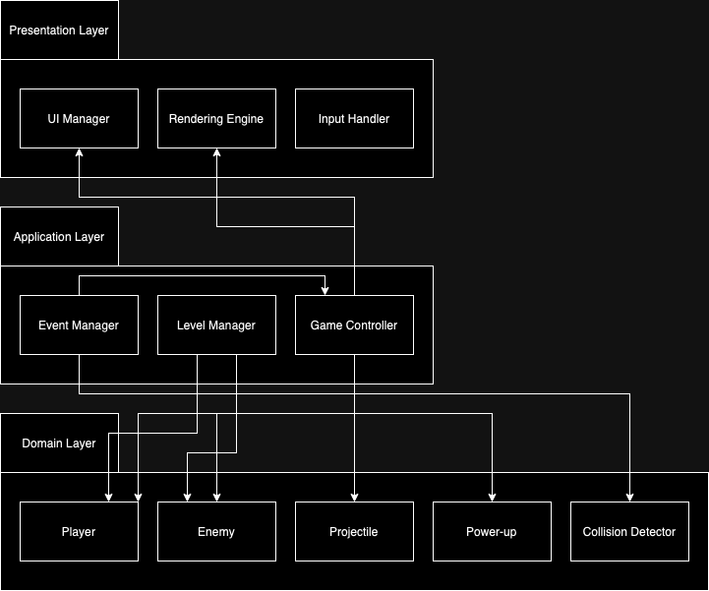

## ***Use Cases and Usage Scenarios***

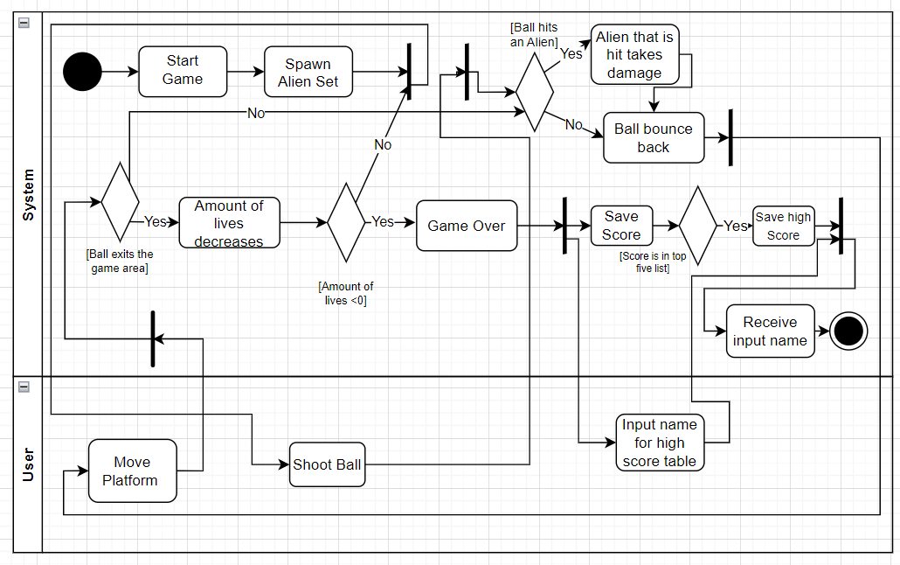

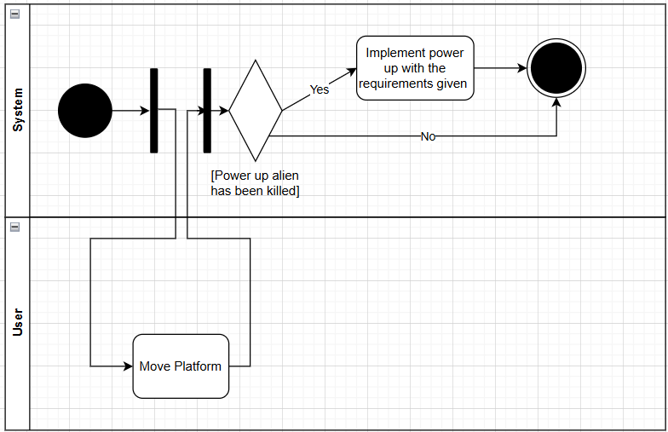

## ***System Requirements Specification***

**SRS-SB-002.1**The game shall spawn waves of enemies that move in a predetermined pattern.

**SRS-SB-003.1**The game shall enable players to move a platform left and right to deflect a ball that damages enemy aliens.

**SRS-SB-004.1**The game shall allow the player to shoot a ball, which bounces back upon hitting enemies or the walls of the playground.

**SRS-SB-005.1**The game shall include power-ups that provide the following abilities

* Increase the number of balls in play.
* Increase damage dealt by the ball to enemies.
* Activate score multipliers for a limited time.

**SRS-SB-005.2**

The game shall randomly spawn aliens that can drop power-ups during gameplay.

**SRS-SB-006.1**After the game is over, if the player's score is in the top five, the game shall prompt the player to enter their name for the high score table.  
**SRS-SB-007.1**

The game should be closed after the click on the “Quit” button.

**SRS-SB-008.1**The player shall have a limited number of lives. If the ball exits the game area, the player loses one life.

**SRS-SB-008.2**The game shall display a "Game Over" screen when the player runs out of lives.

**SRS-SB-010.1**

The game shall display the following on the game screen:

* Current score
* Number of lives remaining
* Active power-ups
* Current wave or level
* High score list (after Game Over)

**SRS-SB-011.1**The game shall calculate a score based on the type of enemies destroyed and any active score multipliers.

**SRS-SB-013.1**

The game shall feature four types of enemies, each with different health points and score values:

* Type 1: 1 health point, 50 score on death.
* Type 2: 2 health point, 100 score on death.
* Type 3: 3 health point, 150 score on death.
* Type 4: 4 health point, 200 score on death.

**SRS-SB-014.1**The game shall increase difficulty over time by increasing enemy speed, spawn rate, and adding more powerful enemy types.